From online:

If you've been working with databases for a while, chances are you've heard the term normalization. Perhaps someone's asked you "Is that database normalized?" or "Is that in BCNF?" All too often, the reply is "Uh, yeah." Normalization is often brushed aside as a luxury that only academics have time for. However, knowing the principles of normalization and applying them to your daily database design tasks really isn't all that complicated and it could drastically improve the performance of your DBMS.

What is Normalization?
Normalization is the process of efficiently organizing data in a database. There are two goals of the normalization process: eliminating redundant data (for example, storing the same data in more than one table) and ensuring data dependencies make sense (only storing related data in a table).

From Wiki:

Normalization involves decomposing a table into less redundant (and smaller) tables without losing information; defining foreign keys in the old table referencing the primary keys of the new ones. The objective is to isolate data so that additions, deletions, and modifications of an attribute can be made in just one table and then propagated through the rest of the database using the defined foreign keys.

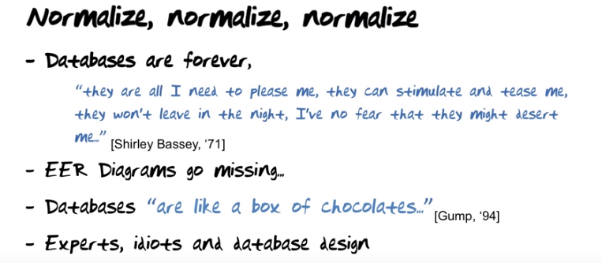
The above figure: The mapping of EER diagrams to relations will in all cases result in a database which is normalized. In spite of that, we still have to learn about normalization. 圖中列的幾點是the reasons yo need to know how to normalize database.

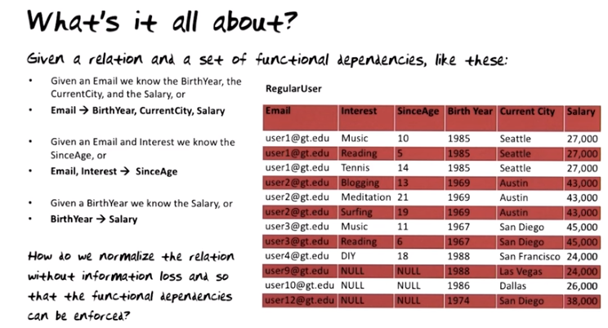

上圖表中的三個User1(兩白一紅)是同一個人, 分成三行列出來是因為他的不同interest.
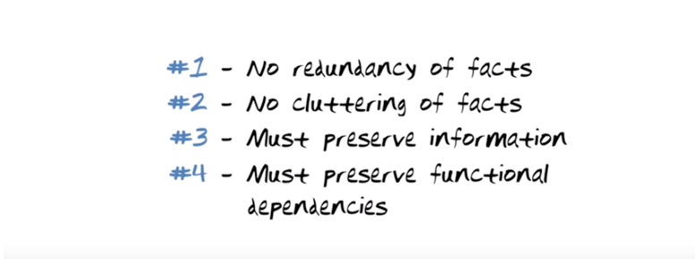
The above figure: Here are the rules you must obey when you normalize relation.

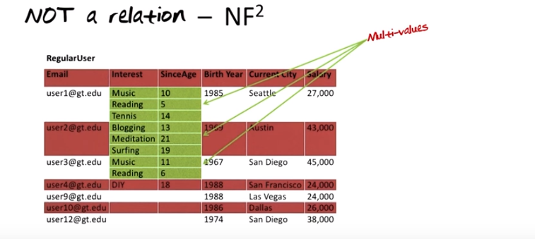
The above figure: you may end up with a data structure that's not a relation, or data structure that we call a non first normal form (NF^2) data structure (haha處). 表中的user1是管Music-10, Reading-5, Tennis-14這三行的, user2是管Bloggin-13, Meditation-21, Surfing-19這兩行的, user3... So take a data structure like this, which is non first normal form and create a relation from it, there is one obvious way we could try to do that: so what if I simply repeat user1 for each one of these rows, …, then I will actually have a relation, 即前面給出的那個有多行user1的表, 也即下圖中的那個表.

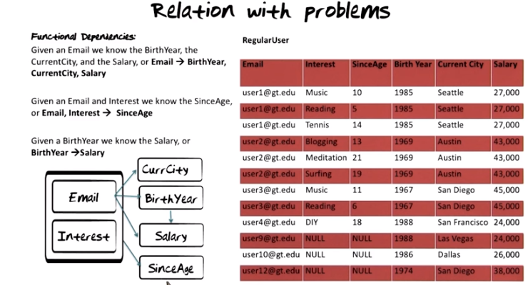

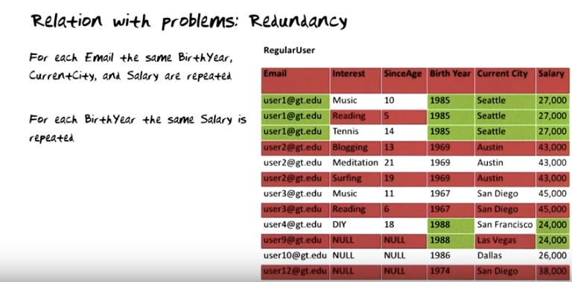
The above figure: redundancy potentially leads to inconsistency. 比如上表中只將第一個user1的城市從Seattle換成了Atlanta, 而其它兩個user1忘了換.

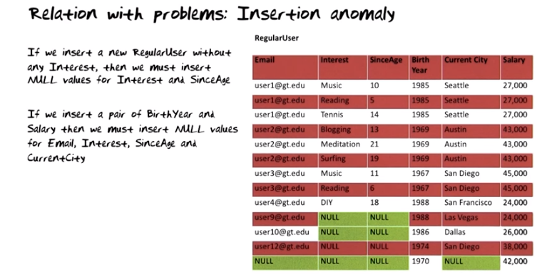

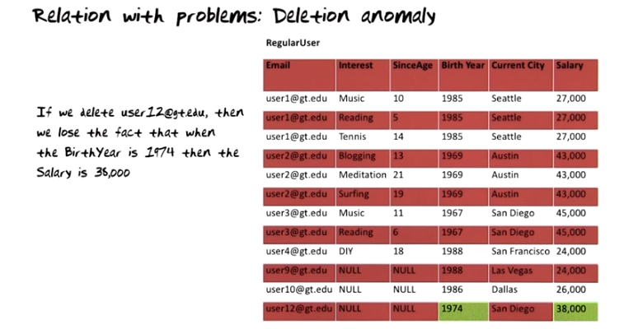

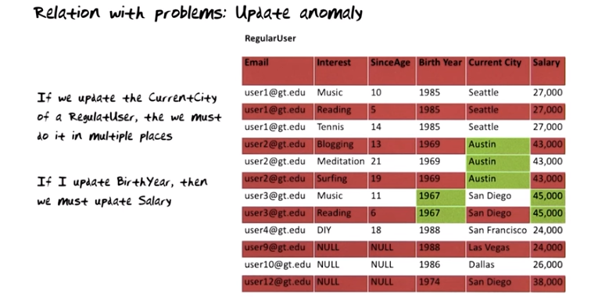
上圖中的”If I update BirthYear, then we must update Salary”的意思是: if you want to update the salaries that are made by people with BirthYear 1974, you gonna have to remember to do it everywhere.

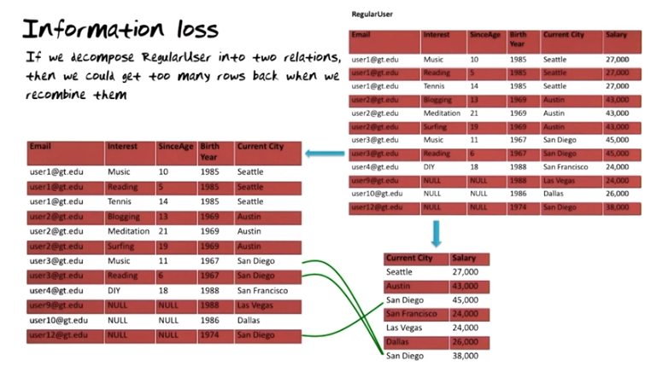
上圖的意思是將兩個小表合並時, 對於San Diego, 有兩種連法, 一種是依按之前的表, 將user3的兩個San Diego連到4500, 將user12的San Diego連到38000. 另一種是反過來的(如圖中綠線所示), 將user3的兩個San Diego連到38000, 將user12的San Diego連到45000. 這兩種連法都會被包含进 合並後的表 中. So there are two additional tuples added to the result of the joint.... So in other words, when we join these two together, we actually create three additional tuples into RegularUser table that were not there before. This phenomenon is called information loss. You may say: come on, that's a bad name for it because I got more information. Well, getting more information that's not reflecting fact of reality is actually information loss, because now you gonna have three additional rows here and those rows do not relfect facts in reality. Therefore, you have lost your ability to distinguish between the true facts that you started out with and the false facts that were inadvertently(不注意地) added. This is called information loss.

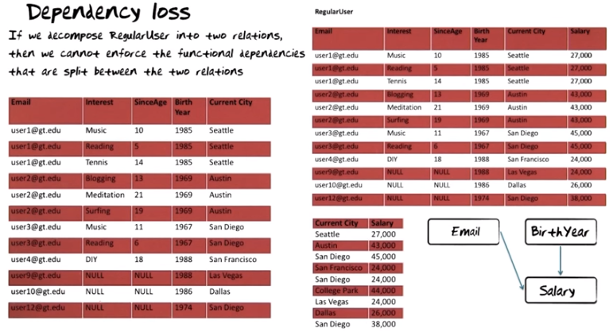
The above figure: We had a functional dependency from Email to Salary. Since Email and salary do not appear together in any of these two new tables. We cannot enforce it within a table. Similary, BirthYear determined Salary. Since the two do not coexist in a table, we cannot enforce them in the table.

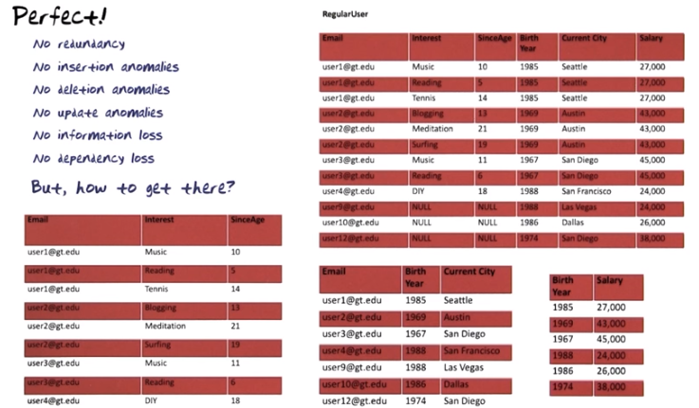
The above figure: Big question is: 我們怎樣才能弄出上面那樣的perfect decomposition?

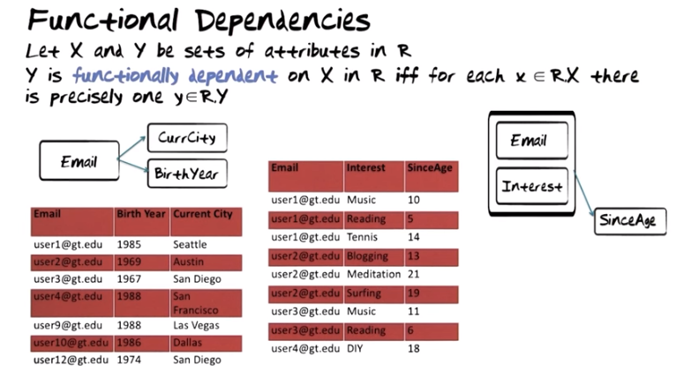

上圖中的iff是if and only if的意思. MO: Functional dependencies的定義其實就是函數的定義, 即y是x的函數. 所以它叫Functional dependencies.

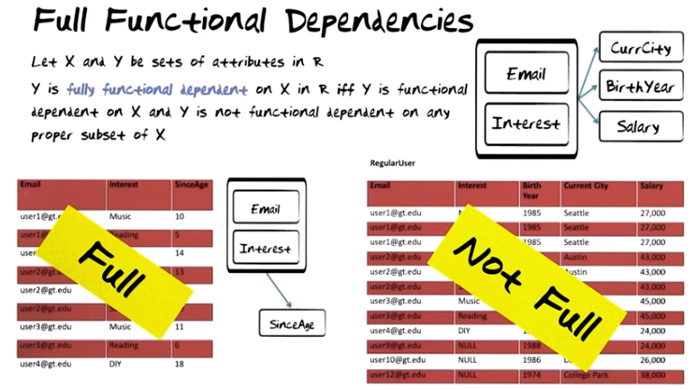
上圖中右邊, Current City is not fully functional dependent on Email and Interest. Why not? Because it's dependent on email alone. You do not need email and interest together to determine a city.

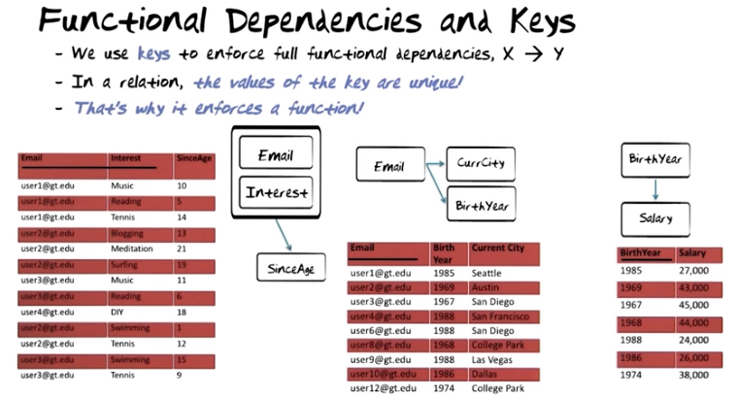
The above figure: So back to the question, then how do you enforce functional dependencies in a relation? The trick simply is that you use keys. So if you want to enforce a functional dependency that X determines Y, then all you need to do is you need to make X the key in that relation.

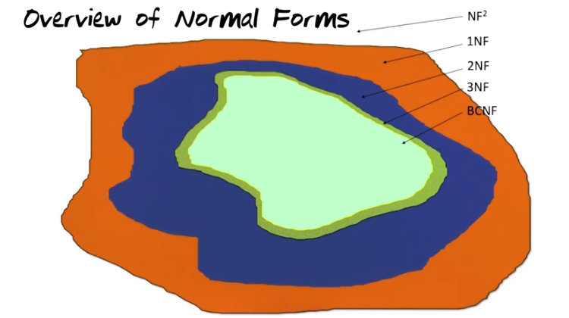
The above figure: Non first normal form(NF^2)之意思見 前面的haha處. The Boyce-Codd normal form (BCNF, 其意思見下) relations are the relations we are aiming at.... As illurstrated by this small small number of relations that are third normal form(3NF, 其意思見下) but not in BCNF. It is theoretically possible that you have a relation in 3NF that's not also in BCNF. However, in practice what happens when you normalize relations from second normal form to 3NF is that you get lucky and you actually end up in where we want to be, namely BCNF.

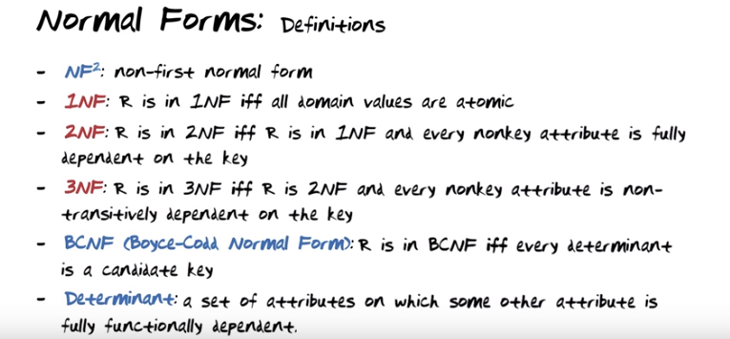

注意上圖中的比如2NF, 是指某一個表是不是2NF. 上圖的定義太formal, 下圖的通俗定義更好懂, 但上圖也有用, 比如若有transitive dependency, 則最多只能是2NF, 不會是3NF. We defined a relation as a data structure where the domain values are pulled from set of atomic values. So in other words all realtions are automatically born in 1NF. Non-transitively: 非可遞.

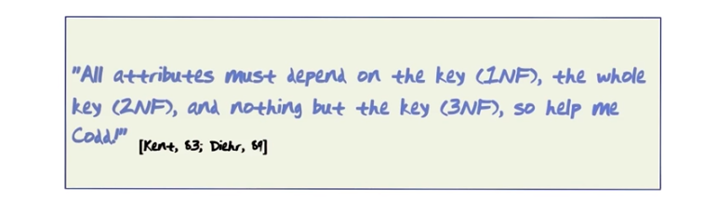
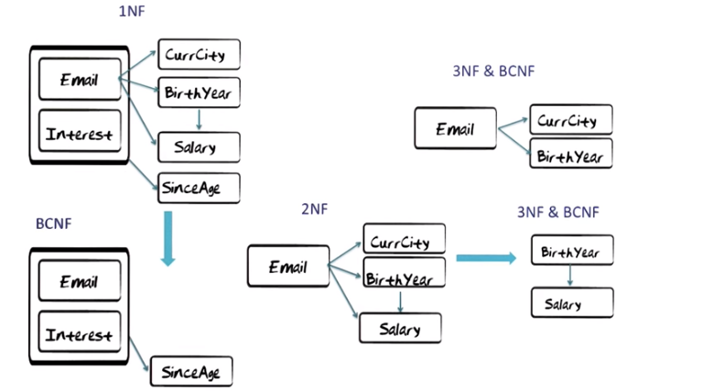

The above figure: so let's take a look at how we can work through these normal forms (即如何把之前的那個表拆成一堆BCNF表). 中間那個是2NF, 是因為they are transitive dependencies: Email determines birth year, which in turn determines salary. 右上那個是BCNF, 是因為the only determinant in this relation is Email, and Email of course gonna have to be the key to enforce those two functional dependencies. 同理, 右下那個也是BCNF.

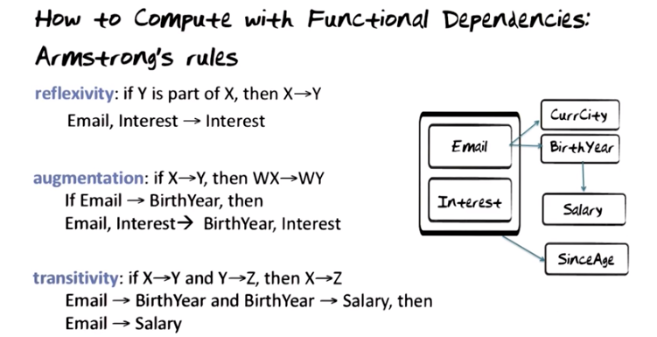
The above figure: to make sure that we do not lose information and that we preserve the functional dependencies when we decompose relations, we need to be able to compute well-meaning(音). The rules for doing that are called Armstrong's rules.

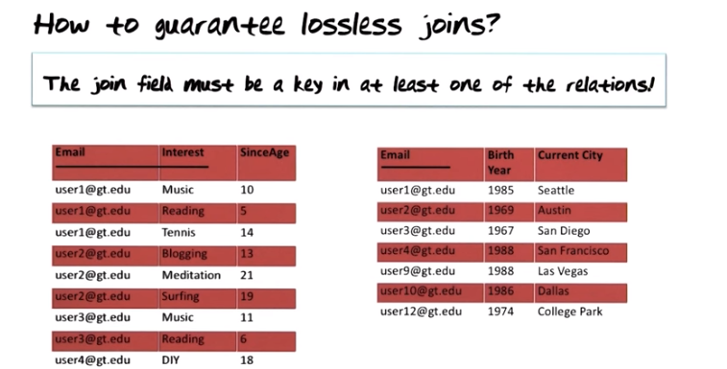
The above figure: when you look at this decomposition here of relation in two relations, then the joint field (joint是指, 我們最開始將初始的表拆成了兩個表, 這兩個表合成為初始的表時, 需要joint, 這就是這裡提到的joint) between these two relations obviously is Email. If Email is a key in one of the two relations as it is here, then we are guaranteed not to loose information from doing this decomposition. In other words, when we joint these two relations together again over Email, then we are guaranteed to not create a disen(音) tuples that were not there in the relation we started out with.

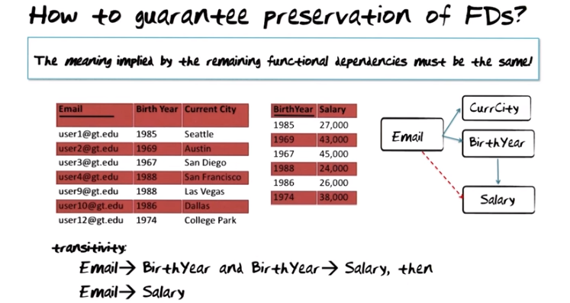
上圖的FD即functional dependency. 方框中完整的句子為: the meaning implied by the remaining functional dependencies must be the same as the meaning that was implied by the original set.

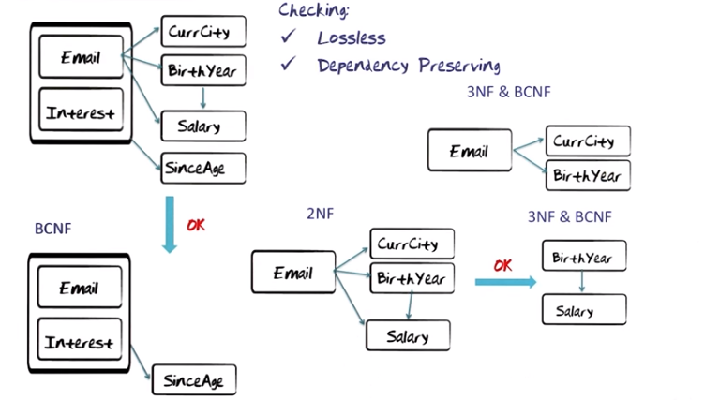
上圖的操作是兩步, 第一步是將初始的表拆為下面那個BCNF和2NF表, 第二步是將那個2NF表拆為右邊的那兩個3NF&BCNF表. 每一步操作時, 都要check該步是否OK(即滿足lossless和dependency preserving). 即整個normalize的過程中, 每一次拆表都要滿足lossless和dependency preserving.

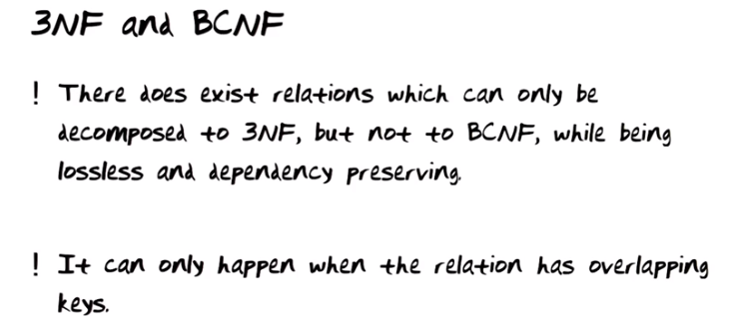
上圖第一點是強調can only be decomposed to 3NF.

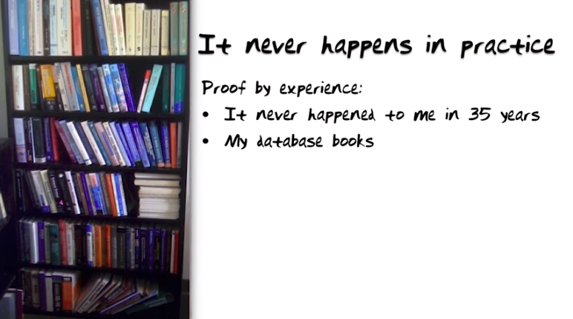
As illurstrated by the Venn diagram this(沒說this指甚麼, 但可從下文知它指甚麼) really never happens in practice. I'm gonna show you a proof by experience. Proof has two steps to it. Number one, it never happened to me in 35 years. I've just designed a lot of database in industry, in government, and in the university, and it never happened to me. As a second part of the proof, take a look at one of the bookcases in my office. So this one book case contains database textbooks only. Every single one of these textbooks has in it a chapter on database normalization. They will show you 1NF, 2NF, 3NF and BCNF. And then coming to the bottom of the right page, it says there does exist relations that can only be decomposed to 3NF and not BCNF. With shaking fingers you turn to page to see such an example, and they changed the example on you. Why is that the case? Because it takes a really sick brain to construct an example like that. So be confident if you follow the steps and bring relations through first second third normal form, you will be lucky and you will end up in BCNF in practice.

